**Technical Report**

**Ben Marriner (220253518)**

# **Project Description**

**Problem:** On days where it could potentially rain, it is not easy to predict exactly what time it will happen, nor if it will happen at all. This is especially the case in Melbourne it is known notoriously for having many seasons in one day. This can leave people not knowing if they should act on it in some way such as, bringing in the clothes from off the clothes line outside or remembering to wear a rain jacket before they go outside.

**Hypothesis:** This project will investigate whether high humidity levels can be used as a warning that it is about to rain. It is predicted that the humidity of the air outside will be at 70% or higher for there to be a chance of rain.

# **System Information**

To investigate temperature and humidity levels to see if rain can be predicted, a prototype has been assembled. The components used are as follows:

## Hardware

* Arduino UNO
* SD Card (16GB is used in this project)
* 1 x Breadboard
* 1 x DHT temperature and humidity sensor
* 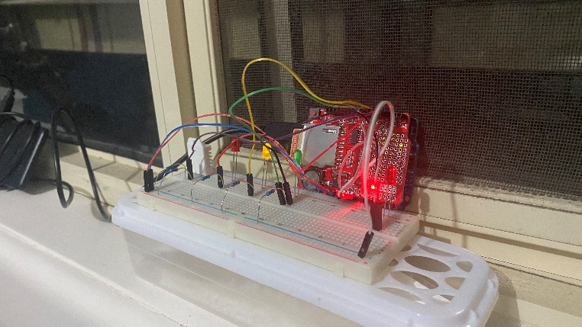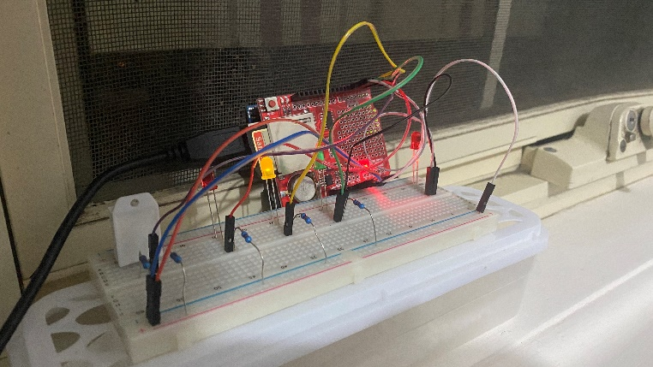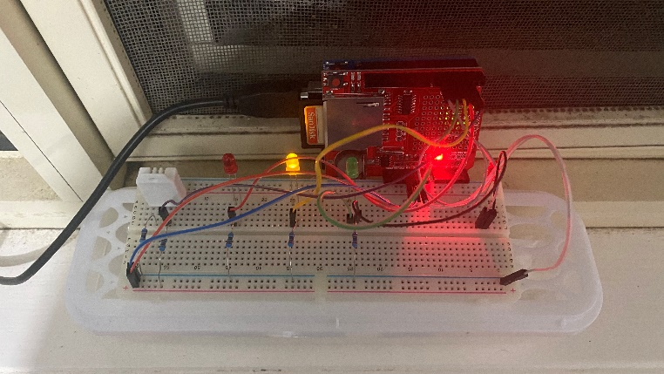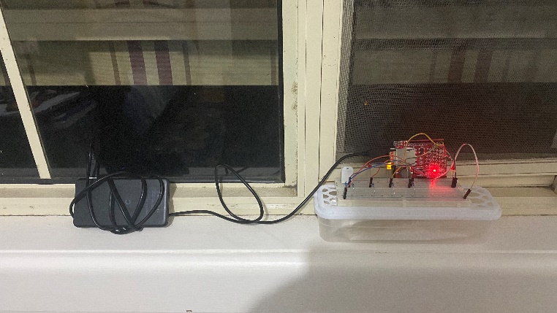4 x LEDs (2 x Red, 1 x Yellow, 1 x Green)

## Software

The Arduino UNO runs a program that makes use of the DHT sensor to monitor and record temperature and humidity data. The software takes a sample once per minute. Based on the temperature and humidity levels the sensor is reading, one of either 1 or 2 out of the 4 LEDs will be switched on.

* Red LED: Temperature is below 14°C
* Yellow LED: Temperature is 14°C or higher and below 20°C
* Green LED: Temperature is 20°C or higher
* Second Red LED: Humidity is at 70% or higher

## Sense:

The prototype uses the DHT to capture temperature and humidity levels.

## Think:

The samples are written to one of the CSV files contained on the SD Card (TEMP.CSV for temperature samples and HUM.CSV for humidity samples). The program works out based on the sample which LEDs should be switched on as explained in the software section above.

## Act:

The appropriate LEDs are switched on and the others are switched off.

# **Data Collection**

The dataset has samples ranging from the 19th of September, 2020 to the 22nd of September 2020. The 19th was when the prototype was first set up, so it did not get to capture an entire 24 hours’ worth of samples. The 22nd was when the prototype was switched off for data analysis, so it also did not capture 24 hours’ worth of samples. Therefore only the data captured on the 20th and the 21st of September was analysed since they were the only two full days in the dataset.

For data that could target the hypothesis to be collected, the prototype had to be set up ahead of a local weather forecast that suggested a chance of rain. The forecast the prototype was set up ahead of did suggest that the 20th and 21st were going to be days that involved rain.

The data itself was pretty clean when it was sampled. This is because I programmed the Arduino to record samples in a format that is easily recognisable by Excel. Upon opening the data in Excel it was only a matter of setting the type of data of the columns to their appropriate types. The data was also filtered to only show samples from the 20th and 21st.

# **Ethics**

The variety of data collected for this project is very minimal. None of the data collected is personal. It is merely data that has been captured from the environment the prototype is placed in (temperature and humidity levels). The only requirements of this project are the components mentioned in the hardware section, access to the Arduino IDE and the knowledge on how to make use of the components.

# **Results**

## Graphs

The highest recorded humidity level was 80.7% and this occurred on the 21st at 8:03:12 AM. On the other hand, the lowest humidity level recorded was 36.3% and this also on the same day at 2:42:35 PM. Throughout the days the prototype was tested, at only 15.43% of two days was the humidity level 70% or above. This would have meant that the humidity LED was switched on during those times. Based on the hypothesis this would have suggested that it was about to rain. However, during none of these times did it rain, nor did it suggest that rain was yet to come. It merely suggested that the moisture in the air was simply at 70% or higher. Similarly, throughout the two days, it did in fact rain at times, however, when the prototype was checked, the humidity LED was not switched on. According to the hypothesis, this would have suggested that it was not about to rain which was not true as it was already raining. In reality, this only suggested that the humidity level was below 70%.

# **Challenges**

The Arduino IDE appeared to be a bit unpredictable. The program’s lack of debugging features made it difficult to develop programs for as some programming errors were not made apparent when they occurred. Unfortunately, there was one issue that caused the Arduino to not record data at all. The issue was that the program did not allow for using constant integers as an argument when calling the delay function. This caused the program to do nothing for the entirety of its operation without any possible warning signs or indications that something had gone wrong.

# **Future Proposal**

Weather, in general, is very hard to predict accurately. If one were to develop a device that can predict rain before it comes, they are advised to design a more elaborate system for a prototype rather than relying on only a DHT sensor. For example, if this is possible, the Arduino could be modified to use a Wi-Fi module so that it can connect to the user’s home network. From there it can retrieve data from a weather website about an upcoming forecast and be able to use that data in conjunction with the DHT and perhaps other sensors to work out the possibility of rain. It is also advisable that more factors are looked at and not just the humidity levels.